Healing Double-Consciousness Through Creative Practice: Moving, Making and the santoor/self
Soosan Lolavar

I sit at my desk in London a little over 24 hours after President Trump ordered the assassination of General Qassem Suleimani – the leader of the Iranian Quds army – consumed by the familiar sense that my fragile British-Iranian selfhood is about to shatter. Predictably, the news is covered in images of mass gatherings of Iranians – men beating their chests, women gripping their black chadors – an undertone of crazed savagery present throughout. I feel like I am being split in two.

I struggle to disentangle my being from Orientalised representations of Middle Eastern barbarity to such an extent that the tone of such coverage causes me to fear and loath myself. At the same time, I am aware of my positioning as an elite British voice: a voyeur from London observing from afar conflicts from which I am fundamentally safe, and the beneficiary of systems of colonialism which amplify my voice more than any member of my extended family. As a British Iranian person I am implicated as both object and subject within such processes, and the weight of such knowledge threatens the collapse of my internal self. I feel a deep fissure opening up inside me, a triggering of old wounds and a re-igniting of a sense of myself as broken, ambivalent and lost.

Double-consciousness
Du Bois’ concept of double-consciousness (which most notably appears in the 1903 The Souls of Black Folk) describes the psychic experience of embodying two oppositional ideas – the “negro” and the “American” – within one human self. This experience exerts huge emotional pressure on the individual who is overwhelmed by:
this sense of always looking at one's self through the eyes of others, of measuring one's soul by the tape of a world that looks on in amused contempt and pity. One ever feels his two-ness - an American, a Negro; two souls, two thoughts, two unreconciled strivings; two warring ideals in one dark body, whose dogged strength alone keeps it from being torn asunder (Du Bois, 1994: 2).

Double-consciousness leaves the black person in America unable to conceive of themselves outside of racist structures which devalue and degrade their humanity. This renders the individual in a constant state of tension, essentially splitting their personhood in to two warring parts (Martinez, 2002: 170). While such an experience is deeply destabilising for the black self, the dual awareness that it produces means the individual is also ‘gifted with second-sight’ (Du Bois, 1994: 2): a particular type of insight gained by the oppressed about the world and their place within it. This awareness is essential to the construction of a culture of opposition such that, second-sight ‘raised to a conscious level, cultivated, and directed - has revolutionary potential’ (Holt, 2001: 109 quoted in Ciccariello-Maher, 2009: 379). Thus while double-consciousness is a destructive force in relation to the sanctity of the self it is also a productive one which furnishes the individual with particular abilities, even a gift.

Gilroy’s seminal publication The Black Atlantic (1993) presents operations of double-consciousness on a global rather than individual scale. While Du Bois explores the disruption of black individual personhood, Gilroy explores the dislocation and reformulation of black culture through the movement of black bodies between Africa, the Americas and Europe. The triangulation of these three points – The Black Atlantic – describes a culture that is:

a chaotic, living disorganic formation. If it can be called a tradition at all, it is a tradition in ceaseless motion – a changing same that strives continually towards a state of self-realisation that continually retreats beyond its grasp (Gilroy, 1993: 122).

Histories of forced and voluntary migration across the Atlantic effect both an entanglement between dominant and subaltern cultures and a splitting of the black self-writ-large into a diasporic multiplicity. Again, such a process is not defined only by destruction but also by production and creativity. Gilroy utilises the dual nature of double-consciousness as a means for discussing the inherent syncretism of black culture, with particular reference to black musics created at the interstices of diasporic interactions.

The power of mixture is also relevant in Anzaldúa’s (1999) concept of Mestiza Consciousness. She presents a harrowing account of Mestizo/a people (Mexicans of mixed Spanish and Indian descent) and Chicanos/as (their Mexican-American descendants) having endured centuries of conquest, loss of land, death and pain (Anzaldúa, 1999: 27ff). It is from the crucible of this history and as a result of her particular experience as a lesbian, Mestiza/Chicano woman living at the borderlands of Mexico and the US that she constructs a powerful sense of self:
The new mestiza copes by developing a tolerance for contradictions, a tolerance for ambiguity…She learns to juggle cultures. She has a plural personality, she operates in a pluralistic mode - nothing is thrust out, the good the bad and the ugly, nothing rejected, nothing abandoned (Anzaldúa, 1999: 101).

Mestiza consciousness allows Anzaldúa to resist the various axes of gender, race and ethnicity and set up a space of belonging that exists at the “borderlands”, a kind of crossroads where a variety of ideas meet and overlap. Much like Du Bois’ concept of second-sight, Anzaldúa refers to “la facultad” – the unique ability of the individual to understand the world and one’s place within it (Martinez, 2002: 169) – as a particular product of subjugation, formed especially from experiences ‘when we're pushed against the wall, when we have all sorts of oppressions coming at us’ (1987: 60).

Du Bois, Gilroy and Anzaldúa all affirm both the violence endemic to processes related to double/mestiza consciousness, and the fact that such experiences are inherently productive, furnishing the individual with particular abilities and making possible certain kinds of creative response. My own history of double-consciousness certainly the affirms the pain and confusion that lies at the heart of this experience and the creativity required to contort your way out of it. From a young age I had a clear understanding of two central facts about myself. Firstly, that I was fundamentally an outsider and that fitting in was essential to life, and secondly, that it was only through hyper-vigilance and continual self-management that I would have any chance of surviving my dual identity. Born to an Iranian father and British mother in south London, and existing between an Iranian diaspora community, my broader life in London (overwhelmingly populated by white British people), and my Iranian family in Iran, I soon acquired almost virtuosic skill at re-shaping myself to fit into any given situation. My continuous self-awareness strongly echoes Anzaldúa’s (1987: 60) description of la facultad as ‘an instant “sensing”, a quick perception arrived at without conscious reasoning…the one possessing this sensitivity is excruciatingly alive to the world.’

My practice of code-switching served a very particular purpose, since I cannot remember a time before I “knew” that my Iranian self was strange and foreign: something that had to be kept hidden from non-Iranian people in the UK. As a child I had a deep fear of people meeting my father and finding out just how foreign both he (and I) really were. At the same time I was terrified of him being mocked or harassed and sought to constantly shield him from potential racial abuse. This led to me pushing him to edge of my life for many years for fear that his foreign body might unwittingly put us both in danger. My constant vigilance meant that, while never explicitly denying my Iranianness, I was able to present an uncomplicated sense of Britishness to the wider world for many years. The effectiveness of this presentation was made especially clear to me during a particular experience in which British friend of mine told me he had become friends with an Iranian man at work who had “single-handedly changed his opinion on Iranian people.” Confused, I asked what he meant and he went on to explain to me how he had previously thought of Iranians as generally untrustworthy and unwilling to integrate into British society. I stared open-mouthed and speechless as I watched someone I had known for over ten years describe myself and my family with such flippant opprobrium. On seeking solace with another friend that evening they looked confused at my distress and remarked: “but you’re so British, why would that upset you?”

At the same time as I exhausted myself trying to play the part of a British person, I felt fundamentally rejected by aspects of Iranian society and disconnected from my Iranian self. At the Iranian diaspora community group we attended every Saturday for over a decade, my sister and I were called “not real Iranians” time and again by children and adults alike. Such terms were used to admonish us for the poor quality of our Farsi, to congratulate us for our punctuality (Iranians being stereotypically tardy) or to joke about our inability to perform the Iranian version of clicking called beshkan. A crucial backdrop to these pronouncements was the idea that otherness was central to the Iranian diaspora experience in the UK and due to mine and my sister’s passing privilege – unlike some of our friends, we were not called “Pakis” on the bus – we could never be fully considered part of such an experience. I began to experience my Iranianness as an objective entity that was both fragile and unfulfilled, something that I continually failed to achieve and whose legitimacy could only be affirmed by other people.

My early life experiences saw me trapped between two worlds: suppressing my Iranianness in wider British society at the same time as labelled “not a real Iranian” by some members of my Iranian diaspora community. The backdrop to both of these experiences is a British society in which to be Iranian is to be fundamentally ‘other’. This othering of Iranianness led to suppression of my Iranian self, while this same mechanism (and the effectiveness of my self-presentation as ‘not-other’) lay behind my experience of rejection by some diaspora members. As such, I struggled to construct a sense of identity that accounted for my dual heritage, experiencing the dislocations of double-consciousness in which Iranianness is constructed as an external and objective “thing” that is at once ambivalent, dangerous and unfulfilled.

Over the years I have increasingly brought my experiences to bear on my compositional output, writing a range of pieces that explore Iran and Iranian culture in a variety of ways. In this way, my work aesthetically realises Du Bois, Gilroy and Anzaldúa’s constructions of the productivity inherent to the experiences they describe. Recently, however, I have come to see my compositions as not just a reaction to double-consciousness but as a way of confronting and even healing the fissures and dislocations it creates. I would argue that it is not just that double-consciousness is an experience with creative potential, but rather that there is something about the process of creative practice that speaks directly to double-consciousness. That creative work – defined as ongoing practices of making and moving – has the potential to attune us to the inherent entanglement between maker and materials, enabling a means of conceiving of ourselves as inherently intertwined with the world. This awareness stands in stark contrast to the dislocations and fissures characteristic of double-consciousness, with the potential to challenge and even overcome these alienations.

Focusing on a single example of my creative work – a piece entitled Inventory of My Life – this chapter explores how processes of body extension and adornment enable me reconsider my sense of alienation from an Iranianness constructed as external and ambivalent. Specifically, I argue that processes of performance and improvisation within Inventory of My Life enable the construction of the santoor / self, a cyborg-being enjoining myself and santoor into a network of becoming within which gesture and touch become the basis for a kind of thought. In this context, the santoor stands as a symbol of a bounded and reified Iranianness from which I have previously felt alienated and dislocated, and thus the creation of the santoor/self engenders a radical unification. Further, this cyborg-being becomes the site of adornment and embellishment through which I am able to creatively explore the limits of this network of being. This process of transformation enables an understanding of my Iranianness not as an objective reality from which I am alienated but as a process of becoming produced moment to moment in my engagement with, through and of the world. This awareness stands in stark contrast to the dislocations and fissures characteristic of double-consciousness, and as such work with the santoor / self has the potential to challenge and even overcome these alienations.

Making, Moving and Technologies of the Body

A key means by which the santoor/self is produced is through technologies of body extension and adornment in the performance of Inventory of My Life. It could be said that all technologies are, fundamentally, extensions of the body. If technologies refine our ability to explore the world around us, they are in essence devices for developing processes of (among other things) sight, touch, hearing and thought which begin in the human body. As Macluhan and Fiore (2005: 31-40) put it:

the wheel
…is an extension of the foot
the book is an extension of the eye…
clothing, an extension of the skin…
electric circuitry
an extension of
the
central
nervous
system

Further, ongoing use of these technologies in turn modulates thought and action such that, ‘we shape our tools, and thereafter our tools shape us’ (Culkin, 1967: 70). Thus, humans at once ‘create inspiring and empowering technologies’ at the same time as they ‘are influenced, augmented, manipulated, and even imprisoned by technology’ (Hurme and Jouhki, 2017: 145, emphasis added). In this way the relationship between tools and bodies can be conceived as ongoing and circular.

The connection between technological devices and the human form has been particularly explored by artist Rebecca Horn (b. 1944) who reflects on her own history of illness in order to consider the role of prosthesis.

In 1964 I was 20 years old and living in Barcelona, in one of those hotels where you rent rooms by the hour. I was working with glass fibre, without a mask, because nobody said it was dangerous, and I got very sick. For a year I was in a sanatorium. My parents died. I was totally isolated. That's when I began to produce my first body-sculptures.

Thus during a period when her ability to physically commune with the world was severely limited, she began to produce sculptures that would enable her to reach beyond the length of her physical form. Her 1972 work, Handschuhfinger (Finger Gloves) (see figure 1) extends the reach of her own hands such that she can ‘feel, touch, grasp with them, yet keep a certain distance from the objects that I touch’ (Horn et al., 1997: 58). Horn’s sculptures produce a sense of intimacy and detachment at the same time, elongating the sensitivity of her fingertips such that she can feel objects that are far beyond her reach, while at the same time producing the gloves as a barrier between herself and the items that she grasps, in a sense separating her from what she touches. The gloves act as an extension of her body at the same time as her body is subsumed into the technology of the gloves, setting up a relation in which subject-object distinctions becomes shifting and unstable.
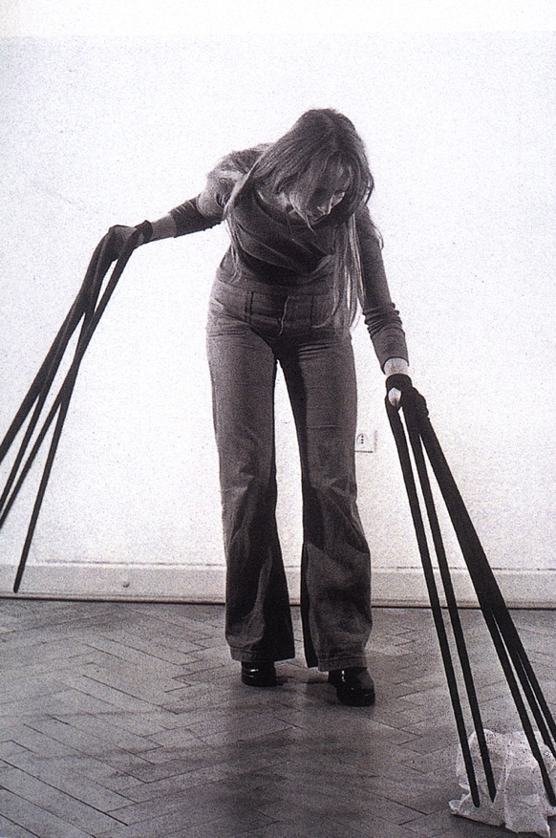
Figure 1 Handschuhfinger (Finger Gloves) by Rebecca Horn, 1972.

Similarly, Merleau-Ponty (2012: 144) utilises the image of a blind man and his cane to explore technologies of body extension. As he explains:
The blind man’s cane has ceased to be an object for him, it is no longer perceived for itself; rather, the cane’s furthest point is transformed into a sensitive zone, it increases the scope and the radius of the act of touching and has become analogous to a gaze.

The cane gradually becomes a part of the blind man’s body at the same time as the man’s body comes to be an elongation of the cane. In both cases, subject-object distinction gradually disappears as practices of use intertwine body and technology in ongoing loops of engagement.

One way of thinking about how haptic relation gradually dissolves separation between “person” and “thing” is through the analogy of correspondence between maker and materials:

I want to think of making…as a process of growth. This is to place the maker from the outset as a participant in amongst a world of active materials (Ingold, 2013: 21, emphasis in original).

As Ingold describes it, maker and materials correspond in such a way that subject-object boundaries begin to blur. Haptic engagement – feeling, bending, splitting, breaking and moulding – effects a correspondence such that maker and material ‘join forces’ (ibid.) and act together. It is not only a sense of touch that guides the maker but a feeling of moving with and amongst materials that is also key. Indeed, it would be impossible to separate relations of making and moving from each other since materials are mutable entities and the artisan is in a constant state of following this flow (Deleuze and Guattari, 2004: 450-51 quoted in Ingold, 2013: 25). As such the entanglement of making-moving can be considered an example of what dance theorist Sheets-Johnstone calls thinking in moving:

I am wondering the world directly, in movement; I am actively exploring its possibilities and what I perceive in the course of that wondering or exploration is enfolded in the very process of moving (Sheets-Johnstone, 1981: 402).

Sheets-Johnstone (1981: 400) builds this concept in contrast to assumptions which both tie thinking and rationality together and construct ‘thought’ as that which precedes and directs movement. Instead, she posits that thinking in moving interlaces thought and gesture such that bodily movement becomes a means for exploring and understanding the world. Bodily movement does not follow from thought or encapsulate thought, it is its own kind of understanding through which the world is both perceived and created. Drawing on Ingold and Sheets-Johnstone we could thus think of processes of making and moving as producing a network of being within which maker and materials are intertwined. Within this network thinking in moving occurs such that gesture and touch become the basis for a kind of thought. Since the flow of materials plays a key role in guiding the maker’s movements, this conception allows for the fact that materials have an active role to play in producing the particular thought processes of this network.

It is against this backdrop that my own work with the santoor emerges, with particular interest in the extent to which such ideas can be brought to bear on the frame of double-consciousness. Specifically, how can work which entangles human and non-human, my body and the body of the santoor establish a relation in which subject-object binaries break down as a result of an ongoing relationship between maker and materials. And when the “material” of this relation is an ethnically-marked instrument, what effect could this relation have on my experience of the splittings of double-consciousness?

The santoor

A hammered dulcimer made of wood with brass and copper wires, derivations of santoor can be found in – among other countries – Iran, Iraq, India, Turkey, Greece, Tibet and China, with earliest references to a prototype of the instrument dating back to the ancient Babylonian era (1600-911 BCE).. References to the ‘santir’ feature in the old testament where it formed part of the orchestra of Nebuchadnezzar, King of Chaldea (604–562 BCE), while Arab sources point to its use in the Sassanian era also (226–641 CE). Today it remains an important instrument within the classical music tradition in Iran and shares the same repertoire as the Iranian tar and setar (Iranian lutes).

While much of the history of the santoor involves its usage as a musical instrument, there is of course no singular, determinate sense in which “the santoor” exists. As Ingold puts it, ‘materials do not exist, in the manner of objects, as static entities with diagnostic attributes…whatever the objective forms in which they are currently cast, materials are always and already on their ways to becoming something else’ (Ingold, 2013: 31). As such, the santoor is a material in an ongoing process of differential becoming, within which its life as a “musical instrument” is a singular possibility. While often engaged in processes of producing sound, it could just as easily function as a kind of perch for birds or a hollow box in which to store money. Broken down for parts its copper wiring could form part of an electrical circuit or its walnut frame could be used to form the top of a small table. Thus the santoor as it currently stands holds within it a range of new possible “becomings”, and the artisan plays a key role in effecting these through processes of touch and movement.

This is not to render the santoor an inert object that is manipulated and altered by human intervention. Each material represents ‘one path or trajectory through a maze of trajectories’ (Ingold, 2013: 31) and the maker plays a key role in opening up or closing down possible routes. Making is thus a correspondence between artisan and santoor-as-material ‘drawing out or bringing forth […] potentials immanent in a world of becoming’ (ibid). Against the backdrop of this loop between maker and material, my experiences with the santoor effect a particular kind of correspondence between myself-as-artisan and santoor-as-material in which – through a relationship of touch, gesture and sound – we are concomitantly produced. A key aspect of this is the construction of the santoor as a representation of Iranian culture.

If the artisan plays a key role in drawing out the potentials of a material in a world of becoming, then my relationship to Iranianness is central to the particular path the santoor occupies within my interactions. My biographical experiences of double-consciousness and alienation correspond with the santoor in such a way as to highlight a singular trajectory contained within – its life as a symbol of a bounded and reified Iranian (musical) culture. The Iranianness that it represents is (of course) constructed. It is a projection of my fears and anxieties and as such it portrays itself as objective, authentic and ultimately hostile. Through my kinaesthetic and haptic correspondence with it, the material of the santoor comes to “represent” my experiences of alienation. Since relation between artisan and material is iterative, I similarly follow the flow of this particular becoming of santoor and am led down familiar paths that reflect on the nature of my dual self, the estrangement I feel as British-Iranian and my sense of failure at never being “whole” in any place.

This ongoing loop seems, at first, to offer no way out of the fissures and dislocations inherent to double-consciousness – the more I try to commune with a material representing Iranian culture, the more I feel alienated from it; the more I feel distanced from it, the more I re-create it as an objective symbol of all that I fail to be. However as processes of performance and direct material engagement develop, there is a gradual dissolving of the separation between myself and the santoor. This enjoins maker and materials into a cyborg-being called the santoor/self, a singular network of being within which its own form of thought flows and which has the potential to heal the splittings of double-consciousness.

Learning to Play

The process by which the subject-object distinction between santoor and self gradually dissolves predates the performances of Inventory of My Life and, in fact, goes back to my initial experiences of learning to play the santoor in 2015, when I received a Fulbright Scholarship to study Iranian classical music at Carnegie Mellon University in Pittsburgh, USA. My training consisted of a demanding timetable of music classes; weekly lessons in Iranian singing and theory with Dr Reza Vali – a composer and lecturer at Carnegie Mellon; and monthly classes in santoor with Dr Saghafi, a local cardiologist who had studied with Abolhassan Saba, one of the great masters of santoor (as well as violin and setar) performance in Iran. I bought my santoor from Iran in the months before I travelled to the US and took it with me to my new life in Pittsburgh without ever having played a note.

Dr Reza Vali was a supportive and encouraging teacher who understood the complexities of studying Iranian classical music as an adult. Dr Saghafi was more severe and largely dismayed at my lack of aptitude for the instrument. At my first class, he instructed me to practise every day and gave me a book of beginners pieces for santoor. It included a number of well-known folk tunes that I remember from my youth. He instructed me to work my way through the book and see him in a month, informing me that I would be studying a lot of music in quite a short time and so I would be expected to work quickly.

The area of the santoor which is struck when playing measures about 40 x 20 cm, with each note represented by a group of four strings separated from the next note group by about 1cm. The range covers three octaves, with the lowest pitched strings on the right hand side of the instrument and the highest on the left. These strings are hit with hammers called mezrab which are held between the thumb and first finger of both hands, with a lever-like part resting on the remaining fingers. Unlike the piano or harp which both have visual markers to help the viewer quickly identify the names of the notes (the piano, by the arrangement of black keys, and the harp by the red colouring of all C strings), the santoor has no identifying features to guide you as to which string represents which note. This is in part because the santoor does not have a single fixed tuning but is instead flexible according to the dastgah in which it is being played.

The first major difficulty I faced involved moving my hands around in space across the instrument. This movement was not only lateral (as with the piano) but longitudinal also (backwards and forwards across the bank of strings). My initial attempts at playing regularly resulted in me hitting the wrong note, or even several (wrong) notes at the same time. Similarly, I kept forgetting which string corresponded to which note and had to count up from the bottom string (E koron in the tuning I was using) to work out the note names of strings higher up. This resulted in a constant stop-start whenever I tried to play.

As I gradually made my way through the book of beginners pieces, it became clear that I could not read the notated music and play the santoor at the same time, largely because I needed to look directly at the instrument itself, both in order to accurately play a note and in order to “find” the next note in the melodic line. I still struggled to retain a global map of the string-pitch relationships and thus largely moved through melodies by working out the intervals and trying to move up / down the correct number of strings. As soon as I looked away from the instrument, both of these strategies were defunct.

My playing in this early period thus involved looking at a section of the notated music, trying to quickly memorise it and then attempting to play that section on the santoor while looking solely at the instrument. When I came to the end of that section I would look up again, try to memorise another section and again return to the instrument. I would, however, regularly lose my place in the notated music through this constant process of moving between manuscript and instrument. As a result, my playing was slow, awkward and full of long gaps while I returned to the manuscript or searched for the next pitch. Much like David Sudnow describes in the early stages of learning to play jazz piano, I was engaged in a kind of note-to-note thinking, constantly searching for the next string on the santoor or note on the manuscript paper to follow in the sequence (Sudnow, 2001: 12).

My next lesson with Dr Saghafi was a tense affair. He had expected me to finish the whole book and I was barely half way through. He couldn't understand why I was still stumbling over so many of the notes and admonished me for playing the pieces so much slower than the tempo marking suggested. I explained that I was still learning them so had not yet brought them up to speed. I have since learnt that it is a common technique in Iranian music pedagogy to play all music up to speed from the start. It is suggested that when you reduce the tempo, you lose the essence of the music and thus it is preferable to simplify a melody (leaving out the ornaments) rather than playing it at a slower speed.

After a few months of working my way through the beginners book, I moved on to studying the radif, a collected volume of several hundred melody types (gusheh) which form the backbone of the Iranian classical music system. The training of an Iranian classical musician involves strictly memorising all the gusheh within the radif of that particular instrument (Nooshin, 1999: 358). These melody types then form the basis for improvisation, which is not yet taught at this early stage. At first, Dr Saghafi expected me to memorise the whole radif in the 8 months that I was working with him but, on seeing my slow progress, he soon reconsidered his expectations and requested I learn only one of the 12 dastgah, namely Segah.

I was given a book containing the notated version of the santoor radif and also instructed to listen to recordings of the gusheh on CDs that Dr Saghafi gave me. I found the notation generally confusing and quite hard to follow. Much of each dastgah is made up of avaz sections – rubato, unmetered melody types wherein a highly ornamented line gradually unfolds. Conventional five-stave notation is ill-equipped to represent the freedom and flexibility inherent to these sections and without the help of conventional beat groupings, a central pulse or bar lines, the melody types were not clearly represented. Instead I tried to learn largely from the audio recordings Dr Saghafi gave me, using the notation as an occasional reference point. It was painfully slow. I listened to a few seconds of the audio at a time, then paused it while trying to play this on the santoor; pausing, repeating, pausing and repeating over and over again. I gradually inched my way through each melody type over hundreds of hours. It was laborious work, and very hard to memorise so many melodies which all sounded quite similar to my ears. It was a common error for me to start playing one gusheh and then imperceptibly blend into another without realising.

The effect of this more aurally focused way of learning, alongside the relegation of the notation to serving only as a reference point, meant that I progressed from the note-to-note thinking described previously (Sudnow, 2001: 12), onto a phase that Sudnow describes as ‘ “going for the sounds” ‘ (Sudnow, 2001: 40). Crucially, this changed my experience with the santoor from a process of de-coding to one of sonic thinking in moving.

To explain what is meant by “going for the sounds” it is useful to consider first the several step process involved in my initial attempts to play the santoor:
- Observe the visual representation of a section of the notated music.
- Convert this representation into a series of pitches and rhythms.
- Move my attention to the santoor and ascertain which string corresponds to the starting pitch of the musical section.
- Use intervallic relationships / global string-note name recognition to connect the series of pitches and rhythms observed on the page to string positions on the santoor.
- Strike those strings with the hammers.
- Return to the manuscript to observe the next section of music.

You will note that the physical movement of my body and the sounding of the instrument are only of central relevance in step 5 of this six-step process which is otherwise largely focused on a process of de-coding notation and then re-coding its relationship to the santoor. This period is therefore characterised by a clumsy and slow process in which sounds became symbols which then had to be interpreted in the context of a new instrument before eventually reproducing sounds once more.

In contrast, my aurally-focused process for playing the radif enabled a kind of sonic thinking in moving (Sheets-Johnstone, 1998) in which thought, gesture and sound became interlaced. Over time, rather than struggling between notation and instrument, I developed an embodied sense of where my hands had to move in order to unfold the desired gusheh. This was not just a matter of muscle memory ingraining the movements required for each melody type however, because intertwined in these actions was the very idea of sound also. As Sudnow describes it, ‘how these paths sounded to me was deeply linked to how I was making them. There wasn’t one me listening, and another one playing along paths’ (Sudnow, 2001: 40). This meant that I no longer thought of the gusheh as a series of note names which I then had to re-codify as particular strings on the santoor. Rather, I conceived of the gusheh as a series of sounds, and intertwined in my understanding of these sounds was the very bodily movements required to produce them.

In my earlier exploits with the santoor, the steps numbered 1-4 above had to be carried out before any physical gestures which would produce sound. That is to say, movement followed from or was directed by a particular kind of thought. In contrast, in my later period of santoor playing, thought and gesture became interlaced, such that ‘thinking is by its very nature, kinetic’ (Sheets-Johnstone, 1998: 486). The more I played, the stronger the links between thought, gesture and sound became such that it became impossible to separate my sense of what the gusheh was from the gestures required to produce such a melody and my experience of both hearing and creating those sounds. This made possible a relationship with both santoor and the radif in which, as Sudnow puts it, ‘the body chooses where to go as much as “I” do’ (Sudnow, 2001: 2). This produced a relationship of sonic thinking in moving in which thought and gesture which emanate from my embodied self are intertwined with sound emanating from the body of the santoor and which together produce a network of becoming through which the radif is produced.

We can see here the beginnings of the emergence of the santoor/self as a network of becoming within which sonic thinking in moving operates. While my early experiences with the radif enabled the establishment of this network, it is important to note the ways in which the boundaries of this interaction were still maintained by the norms and ideals of the Iranian classical music system.

The radif is a central ordering principle for performance in Iranian classical music. It was traditionally taught to pupils by a (male) ostad, ‘master’ and used as the basis for improvisation. For many centuries each ostad was likely to teach their own version of the radif built up over many years and thus there was great variation in their content. By the mid-nineteenth century, court musician Ali Akbar Farahan (1810-55) began to formalise the wide range of gusheh into the modern day radif (Nooshin, 1998: 72).

Iranian classical musicians never play the radif in performance, instead using it as the basis for improvisation. It is only when students have amassed a complete and detailed knowledge of all of the gusheh that make up the radif that improvisation is considered possible, and even then there are strict limitations on the ways they can use this repertoire. Iranian musicians thus perform a balancing act between individual creativity and an adherence to tradition. As Nettl (1974: 14) points out, musicians who deviate too far from accepted models are deemed ignorant and there are strong normatives that prevent them from endangering commonly held conceptions of form or aesthetics. While musicians can creatively use the repertoire as a basis for performance, they can only do so in a way that is generally considered both permissible and comprehensible by other musicians and audience members. This aspect of the music is not taught explicitly and is only gleaned through many years of learning different versions of the radif as well as through extensive performing and listening (Nooshin, 1998: 91).

There has been much debate on the role of the radif within Iranian classical music. Some commentators construct the radif as a singular, authentic, almost sacred text (Nooshin, 2014: 88), an idea which finds its personification in musician and lecturer, Nur Ali Borumand (1906-78). On the other hand, more contemporary musicians such as ney performer / composer Amir Eslami (b. 1971) refer to the radif not as a sacred text but rather as a sound source. As he puts it, ‘if you want to improvise or compose, you need a sound source on the basis of which to express yourself. The two sources which are closest to our culture are Iranian folk music and the radif’ (Nooshin, 2014: 67). Indeed, the meaning of the radif is highly contested and under constant revision. It is certainly the case, however, that discourses of the radif constrain creativity through the ways it both limits improvisation and acts as an authorial canon such that ‘[working] outside the radif automatically places one outside the tradition’ (Nooshin, 2014: 81).

Thus, the radif is a historically located and continually contested limit to creativity in Iranian classical performance. While these boundaries have proved highly productive in Iranian classical music and are, of course, under constant challenge and reconsideration by musicians working with this field (Nooshin, 2014: 157 ff), it remains as a bounded and enclosed form from which improvisation later emerges. This was echoed in my experiences of learning with Dr Saghafi in which the radif could either be performed “correctly” or “incorrectly” in the early stages of memorisation. This has important outcomes on working with the santoor as a means for overcoming double-consciousness.

On the one hand, the aurally focused learning approach to the radif interlaced sound, thought and gesture to produce a kind of sonic thinking in moving in which santoor and self are gradually enjoined. This radical unification has the potential to heal the splittings of double-consciousness through evoking a kind of hybridity in which my body and the body of an ethnically-marked instrument correspond. However, at the same time, the fixed and bounded nature of the radif has the potential to objectify tradition in Iranian classical music, reproducing a sense of Iranianness as a fixed and whole thing which I perceive from a distance and either succeed or fail in achieving, and through which the fissures of double-consciousness are reinscribed rather than alleviated.

Santoor/Self as Cyborg-Being

Following on from the very structured, traditional learning I engaged in with Dr Saghafi, I was keen to explore more experimental means of engaging with the santoor on returning to the UK, and Inventory of My Life offered an effective opportunity to do this.

Inventory of My Life is a 60-minute work for dancer, santoor, tape and projections which was performed in varying iterations in Cambridge (August 2018), Tokyo (September 2018) and London (May 2019). It was collaboratively produced by Kae Ishimoto – a Japanese performer working across Butoh and contemporary dance – Rosa van Hensbergen – a poet, maker, animateur and researcher on Japanese dance – and myself, inhabiting the role of santoor performer and composer. The programme note gives a short introduction to the piece:

[Inventory of My Life] explores questions of inheritance, object attachment, and loss, as they inflect both our personal lives and our lives as makers within specific traditions and cultures. When a person passes away, all the stuff they leave behind is there to be sorted by the rest of us. Instantaneously, items that seemed light, disposable even, grow heavy with the weight of personal loss. The experience of working within a tradition, of having knowledge—somatic, intellectual, technical—passed down to you over many years, can be similarly weighty. And it can be hard to know how to get out from under that weight. Exploring what it means to inherit and disinherit, to store and to generate new stores, takes us as women towards specific lineages, and arrives us at shared metaphors: fabric, threads, clothes and cloth.

At the centre of my practice within Inventory of My Life is an exploration of my Iranian heritage: a consideration of what I keep and what falls away, that which grounds me and that which weighs me down.

In the course of devising Inventory of My Life I explored various practices of experimental santoor performance. It was playing particularly with a 2-metre length of wire (see fig. 2 and 3) that reproduced the experience of sonic thinking in moving I described in my work with the radif, but this time in a way that was uncoupled from normative ideals of traditional Iranian performance. While previous experiences of working with the radif opened up the possibility of a kind of sonic thinking in moving enjoining physical gestures emanating in my body with sound emanating from the santoor, it was the more experimental method of playing with a length of wire that took this relation and extended it, moving beyond the cultural boundaries of the radif and opening up the potential for the creation of a dynamic cyborg-being called the santoor/self. It is through this process that the fissures of double-consciousness are challenged and even healed.

The performance of Inventory of My Life contains an extended section where I play the santoor with a long wire and which represents the gradual emergence of the hybrid, cyborg-being the santoor/self. This being is produced through ongoing correspondence between my body and the body of the instrument, effecting a gradual blurring and then dissolving of subject-object binaries. These positions include: firstly, a positioning of santoor as speaker and myself as respondent; next, relations in which this direction is challenged by me taking on more of a speaking role; and finally a new trajectory of the santoor/self as a cyclical network of iterative becoming. Throughout this process, sonic thinking in moving occurs such that sound, thought and gesture between body and instrument are interlaced.

I thread the heavily rosined wire under the third highest pitched string on the santoor, and begin to pull it back and forth, gradually exploring the sounds it produces. A range of sounds appear– fundamentals of various strings, differing partials and a series of cracking, rumbling and squeaking sounds. These sounds are new to me, I must listen carefully to work out where they are going.
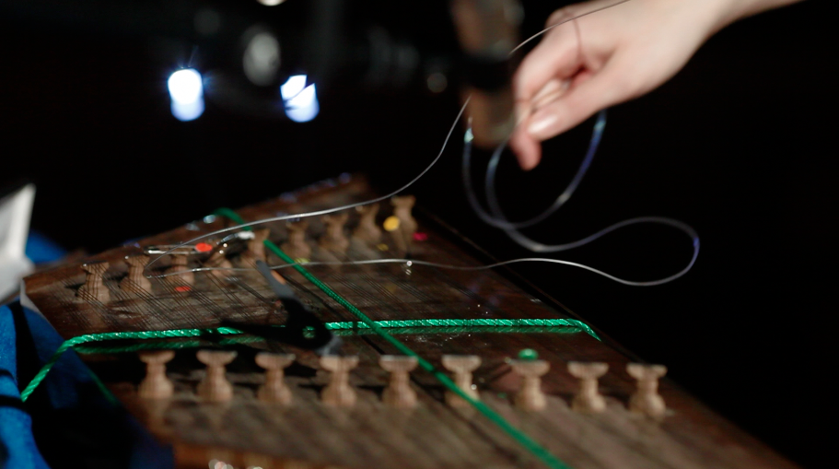Figure 2. The wire threaded around the santoor string.

A single gesture from my body produces multiple sonic responses from the santoor which I then explore and separate through further physical movement. A gestural-sonic relationship is produced which constructs the santoor as speaker and me as respondent. I attend carefully to the sounds it produces and contort myself to uncover the intricacies of its sonic utterances.

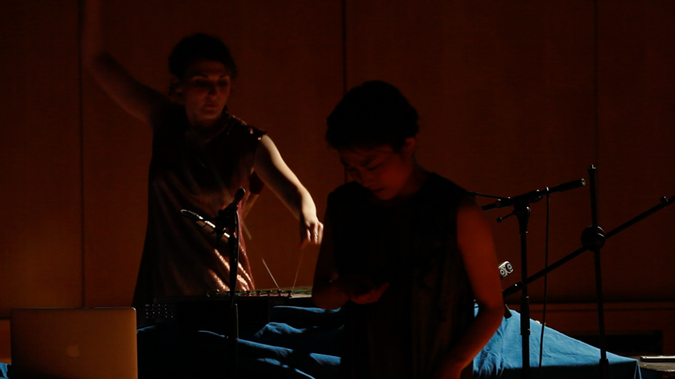
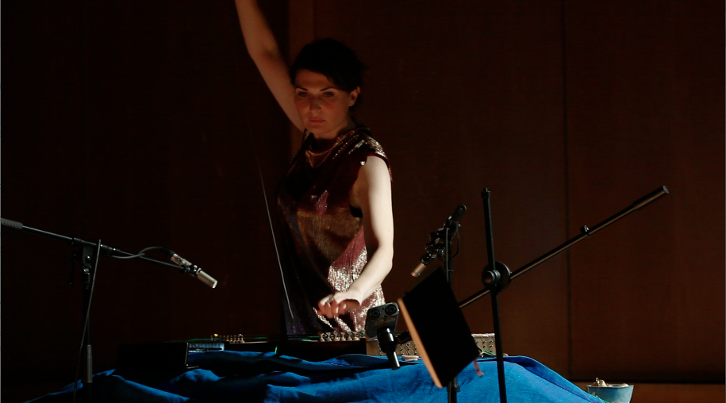
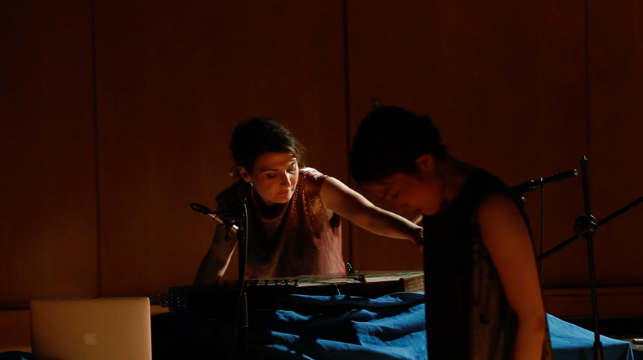
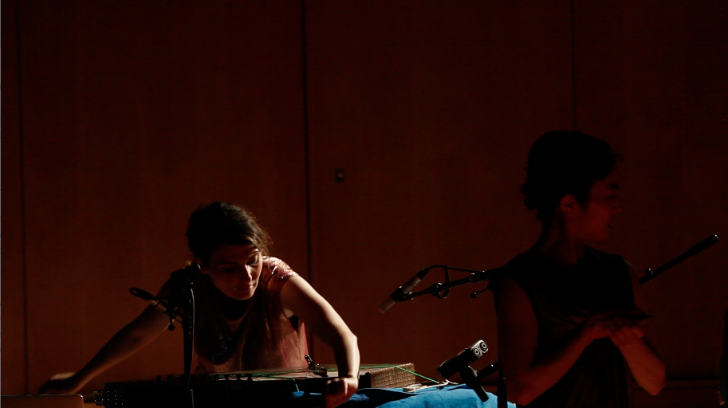
Figure 3. Correspondence between my body and the santoor via a length of fishing wire.

I rhythmically pull the wire back and forth, gradually creating a rhythmic cycle that alternates between fast and slow gestures of push and pull and which causes my body to contort and bend around the instrument. I follow the flow of the santoor material, seeing where it takes me, curiously hearing the sounds as they emerge. The push and pull of the wire coincides with the inhale and exhale of my breath. These explorations are interspersed with moments of silence.

I continue to respond to the utterances of the santoor, a process which begins to effect a cyclical and rhythmic movement of my body and breath. My gestures establish a flow of push and pull, a pendulum-like swing around the santoor as the central point.

- I begin to explore and manipulate the sound potential of the santoor, isolating higher or lower pitches, pulling the string slower or faster and at different angles to produce a range of sounds.

At this point I am able to test the limits of the formerly established gestural-sonic relationship which encapsulates self and santoor. I push back against the tensions of the santoor, finding gestures that are more comfortable to perform and encouraging the its sonic reactions into more pitched territory. My body begins to take on more of a speaking role.

The rhythmic cycles become faster as my physical form takes more control of the production of sound. I focus in on the pitch of a particular partial and feel it vibrate through my body. As I exhale, this particular tone is released back into the instrument through the sound of my singing voice. The vibrations created by my voice send air back into the sound box, vibrating those same strings and partials which effected and produced my own singing. This causes the santoor to sing back at me which in turn effects a response with my singing voice once more.

Here I reverse the cycle of movement in which gestures emanating in my body produce sound vibrating from the strings of the santoor. Instead, I effect physical movement (the vibrating of strings) in the santoor through the production of sound within my own resonating body. These sounds, however, form out of the flow of vibrations from santoor to body, which are in turn instigated by gestures of my body. As such, vibration and gesture cycle between santoor and body in iterative and ongoing cycles. At this point, relations of speaker-respondent have been overcome, and santoor and body function like a single organism, a messy network of wood, wire, bone and flesh through which sound and movement flow like blood pumps through veins.

We can observe how this section of Inventory of My Life represents a process by which santoor and self slowly become integrated into a cyborg-being defined as the santoor/self. This process occurs gradually and is preceded by a number of instances where the subject-object / speaker-respondent relation switches: at times the santoor directs and forms the movement of the body, at others the body pushes back against the santoor, forcing it to follow rather than lead corporeal movements. The flexibility of these roles is key to the construction of the cyborg-being, such that there are moments when the santoor attains a new becoming as a prosthesis to the body, and others where my gestures are an extension of the material of the santoor. This produces a flexible, changing relationship in which the santoor thinks through me and I think through it (Ingold, 2013: 6), entangling us together in a network of becoming.

The backdrop of these relations is ongoing practices of touch, movement and sound which effect sonic thinking in moving, a kind of knowing that operates within this network, and which is embedded in ongoing cycles. This knowing is not bounded by traditional norms of the radif which define the limits of this network and through which I conceive of my relationship with the santoor through binary classifications of “correct” and “incorrect” Iranian performance practices. Instead, a radical unification is effected wherein sonic thinking in moving produces the limits of my hybrid identity as intertwined with my capacity to move, make, think and hear. My Iranianness is no longer a state from which I can be alienated, but it is rather inherently intertwined with my being in and of the world.

Adorning the Santoor/Self

Inventory of My Life not only represents the production of a cyborg-being which unites self and santoor, it also provides the ground on which the santoor/self can be adorned and embellished. A process of transformation which uses wires and bells to expand the physical reach of the santoor/self not only extends the cyborg-being in space, but also facilitates an understanding of this network as a constantly mutating entity. This underlines the new understanding of my Iranianness not as an objective reality that remains fixed, separate and unfulfilled, but as a constantly changing process of becoming in which I am intimately entangled (see figure 4):

A series of wires hang from a lighting grid several metres above the stage, and in the closing minutes of the piece I methodically retrieve each hanging wire one by one and attach it with a safety pin to the fixed strings which lie horizontally along the santoor sound board. There is a soft ‘twang’ as the pin closes and the taut wire bounces gently up and down. The wires stretch high into the air and out at an angle to the left and right, spreading out in all directions by several metres. After I have affixed around ten wires in this way I slowly tie a series of bells to them, seeing them sag slightly under the weight of their new adornments. This process takes several minutes and gradually produces a sculptural installation in which wires and bells sway unpredictably, exploded outwards from the central point of the sound box. Once the sculpture is complete I begin to correspond with it, pushing and pulling at the strings and effecting the tinkling of bells. From time to time we hear a ‘thud’ as my pulling a wire causes the safety pin to hit a string on the sound board again. The expanded size of the sculpture means that I must reach my hands high into the air to pull the wires. I move my body from side to side, several metres across the room to reach the furthest bells.

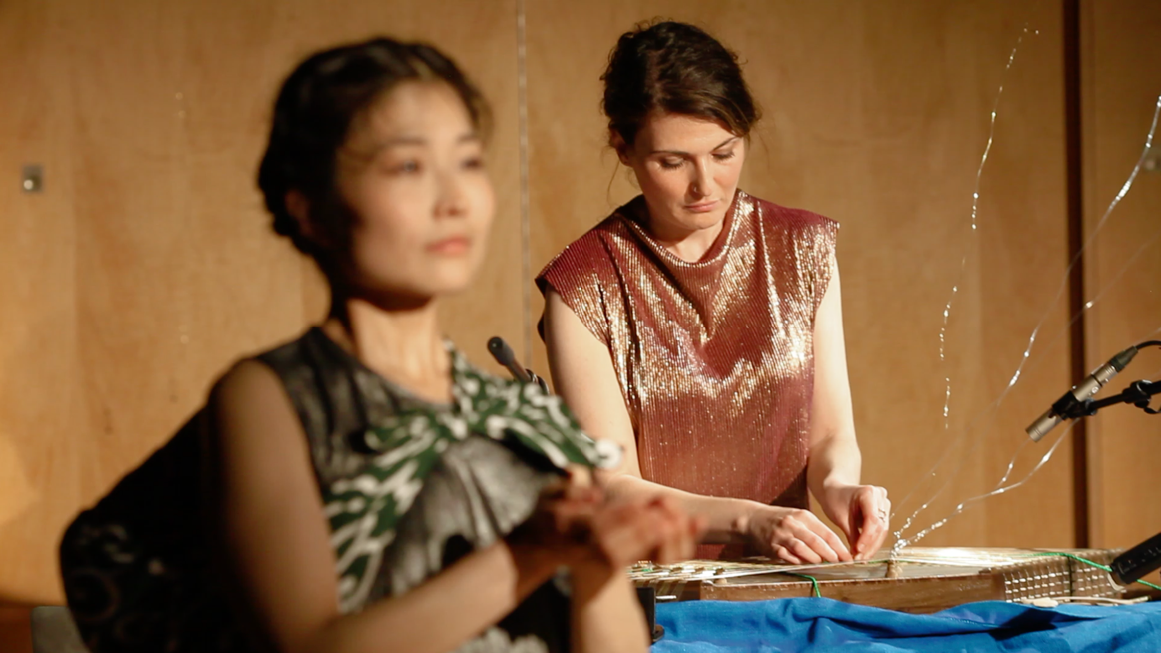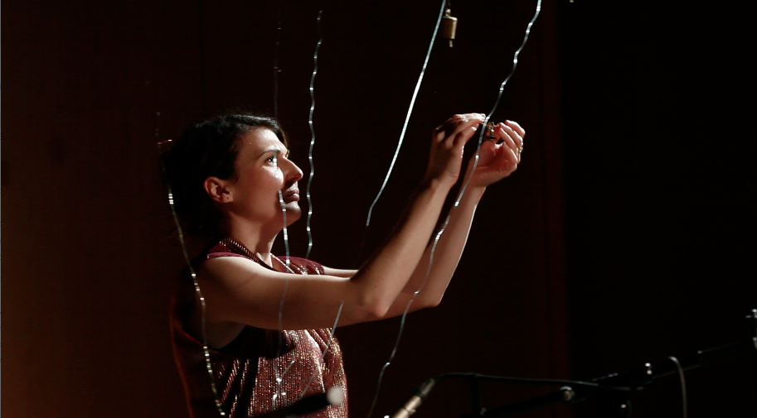
Figure 4. Expanding the santoor/self into an adorned sculpture.

The visual span of the wires in space echoes the arrangement of the strings on the sound board of the santoor, while the bells attached to them reflect their sound-making properties. Equally, the movement of my body in constructing and playing this sonified sculpture recalls the processes described previously in which gesture, thought and sound are intertwined in iterative loops between santoor and body. As a result, this structure comes to stand for a version of the santoor/self which has been expanded to several times its former size. Previously, the capacity of this cyborg-being was contained within a small physical area – defined by the gestural circumference of a single human body and an instrument measuring about a metre in length – and this process of expansion and adornment explodes it into the space. As a result, the newly enlarged santoor/self sculpture highlights the role of transformation and mutability, underlining the capacity of the santoor/self to grow and change. This has particular visual impact because of the way the physical construction of this sculpture both echoes and subverts images of strings which appear earlier in the piece. Indeed, Inventory of My Life opens with a much more threatening use of string material (see figure 5):

The piece begins with each audience member being led into the dimly lit space one by one and directed, via a projection on the wall to: ‘pick up your thread, hold on tight, not too tight’. They take their seat and retrieve the string which is taped to the floor below them. As their eyes gradually adjust to the darkness they slowly realise that the thread they are holding is wrapped around the neck of one of the performers. Gradually, more people enter the room, taking seats in a half circle around myself and Kae. As more threads are picked up from the floor, a web is revealed which shifts and undulates as the audience test their strings. I allow my body to be gently pulled backwards and forwards, watching the threads tighten and slacken around my throat.
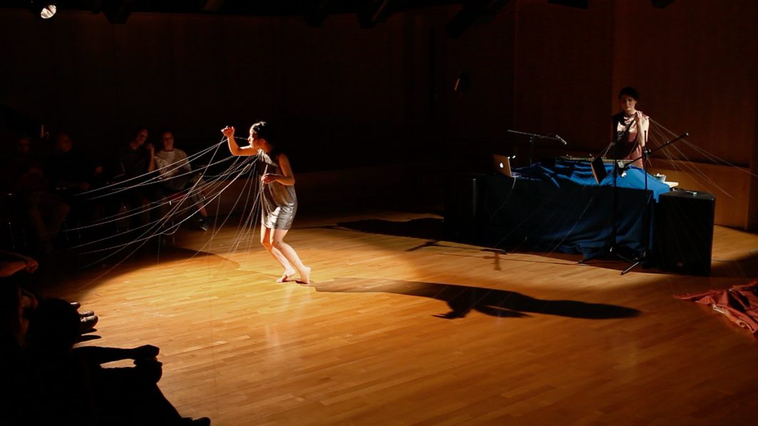

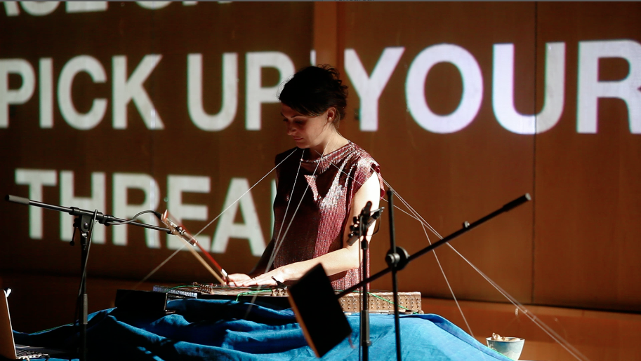

Figure 5. Strings in the opening as an intimate yet threatening web.

The function of threads in this opening is both engaging and oppressive. It connects audience to performer in a direct and material way at the same time as constraining the performer’s ability to move and breathe freely. My gestures are moulded and restricted by a group of people who watch me in the darkness, and while I can respond to the pull of their threads with small movements back and forth, I am ultimately trapped inside the structure that their engagement produces. This sense of being caged and watched by others strongly recalls a dream I had after the third performance of Inventory of My Life in London, whose imagery of splitting and breaking also reflects the dislocations of double consciousness:
12/06/19
Last night, I had a dream I was playing santoor. It was a dark room and I was sitting on the floor. Something else was happening as part of the performance – was it dance? Kae? I couldn’t see, it was so dimly lit. I could barely make out the edges of the instrument but I could sense a ring of people around me, waiting patiently for the performance to begin. I struck the santoor and immediately a string broke. I hit it again and another snapped in two. With every strike something shattered: a string twanged into the air; a piece of wood splintered. With every hammer some new part broke off and flew at me, sometimes hitting me in the face. I kept hammering away regardless, watching the whole thing gradually fall to pieces with my every stroke. After not much time, all that was left was a mess of wood and wire on the floor. I held the hammers limply in my hand and felt hundreds of eyes staring at me expectantly in the darkness.

The contrast between the way my body engages with threads at the beginning and end of Inventory of My Life is stark. While the opening body is static and internalised, the body that interacts with the enlarged santoor/self is mobile and playful (see figure 6). In the closing minutes of the work, I move my body across the space, reaching high into the air to pull and push the wires, acting amongst materials rather than finding myself trapped within the web they form. The closing moments of the piece thus present a possibility of self-actualisation, an image of playful, creative engagement with and through materials that at an earlier point in the work came to stand for entrapment. The creation of this sculptural form thus highlights the capacity of the santoor/self to transform and mutate, challenging hitherto constructions of hybridity as external, fixed and objective. Instead, an image of my Iranianness as a process of becoming is highlighted, the correspondence between my body and the wires onstage exploring how this self is continuously (re-)produced through processes of adornment and embellishment.
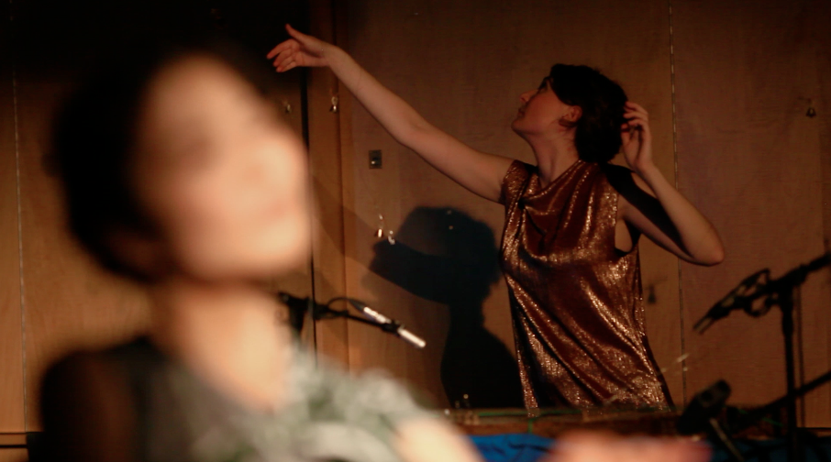

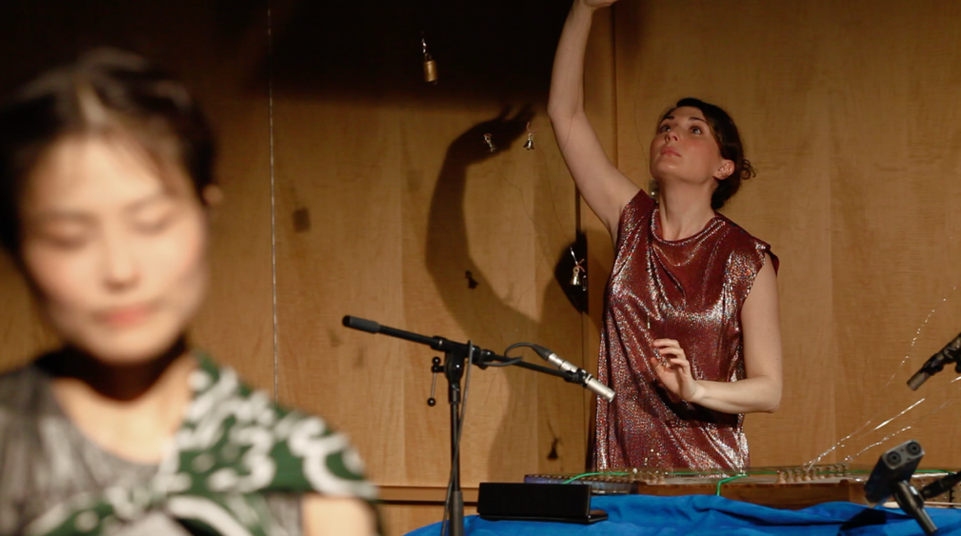

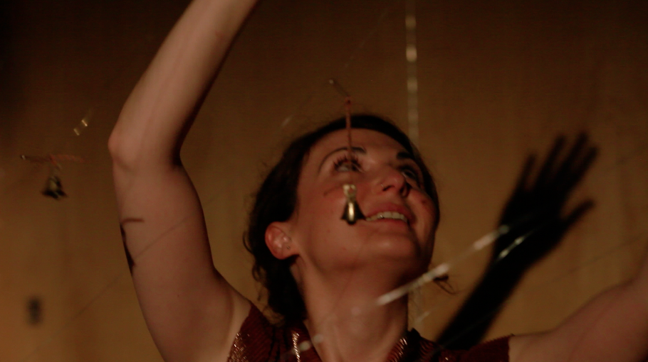

Figure 6. Playing the adorned and expanded santoor/self.

Creative Practice and Double-consciousness
The description of practices of engagement enjoining body and santoor have profound potential impact on the dislocations of double-consciousness. My experiences of such forces have led to the construction of Iranianness as external, objective, ambivalent and unfulfilled, leaving me alienated from an important part of my own lived experience. In the context of my work with the santoor and particularly in the performance of Inventory of My Life, the body of the santoor – representing a reified and bounded Iranianness – is constructed not as an object from which the perceiver is alienated but rather as a material with which the artisan corresponds. Processes of physical engagement produce a kind of sonic thinking in moving which works to gradually dissolve subject-object boundaries between self and santoor. The creation of this cyborg-being (alongside its further adornment and embellishment) explicates how my identity can be experienced as an ongoing, iterative and vital correspondence. This moves beyond subject-object binaries and towards an understanding of Iranianness as an iterative becoming in which maker and materials correspond.

This new insight has therapeutic potential in relation to the dislocations of double-consciousness, an extreme and internalised form of subject-object dualism in which the individual is forced to see themselves only through the eyes of an oppressive dominant culture. This is particularly notable when relations between santoor and self are uncoupled from normative boundaries of Iranian classical music and are thus able to express a more individual kind of hybridity. This cyborg-being surpasses the dislocations and fissures brought on by my life experiences in which Iranianness has been experienced as a subject-object binary imbued with the pain of double-consciousness.

Crucially, practices of engagement with the santoor do not produce this relation so much as attune me to what is in reality a constitutive part of existence. As Barad puts it, ‘we do not obtain knowledge by standing outside the world; we know because “we” are of the world. We are part of the world in its differential becoming’ (Barad, 2007: 185, emphasis in original). That is to say, there is no kind of knowing in the world which is not in some way bound up with the materials that are constitutive of this world. Similarly, my identity is not an entity from which I can be alienated since there is no external reality of my Iranianness which is separate from my existence in and of the world. My identity is a state of becoming in which I am intertwined with my family, my community, my experiences, memories and inheritances. It is created moment to moment in ongoing, iterative and lived experiences and my work with the santoor plays a central role in highlighting this reality. That is to say, sonic thinking in moving crucially allows me to attain an awareness of an already existent sense of communion with the world. Since double-consciousness is, in part, an internalised psychic sense of oneself, new realisations such as these can dramatically contribute to healing the sense of splitting that results from this experience.

Bibliography

Anzaldúa, Gloria. 2012. Borderlands/La Frontera: The New Mestiza. Fourth Edi. San Francisco, CA.: Aunt Lute Books.
Bois, W.E.B. Du. 1994. The Souls of Black Folk. New York: Dover Publications Inc.
Barad, Karen. 1997. Meeting the Universe Halfway: Quantum Physics And The
Entanglement Of Matter And Meaning. Duke University Press.
Ciccariello-Maher, George. 2009. “A Critique of Du Boisian Reason: Kanye West and the Fruitfulness of Double-Consciousness.” Source: Journal of Black Studies 39 (3): 371–401.
Fanon, Frantz. 2008. Black Skin White Masks. London: Pluto Press.
Gilroy, Paul. 1993. The Black Atlantic : Modernity and Double Consciousness. London and New York: Verso.
Harraway, Donna J. 2016. Manifestly Harraway. Minessota: University of Minessota Press.
Horn, Rebecca, Carsten Ahrens, Carl Albrecht. Haenlein, and Kestner-Gesellschaft. 1997. Rebecca Horn : The Glance of Infinity. Scalo.
Ingold, Tim. 2013. Making: Anthropology, Archaeology, Art and Architecture. Abingdon: Routledge.
Lim, Liza. “Post-human songs for the Anthropocene.” Lecture at City, University of
London (online due to COVID-19), 30 September 2020.
MacLuhan, Marshall, and Quentin. Fiore. 2005. The Medium Is the Massage: An Inventory of Effects. Berkeley, CA: Ginkgo Press.
Martinez, Theresa A. 2002. “The Double-Consciousness of Du Bois & The ‘Mestiza Consciousness’ of Anzaldúa.” Race, Gender & Class 9 (4): 158–76.
Merleau-Ponty, Maurice, and Donald A. Landes. 2012. Phenomenology of Perception. Routledge.
Nettl, Bruno. 1974. “Thoughts on Improvisation: A Comparative Approach.” In The Musical
Quarterly 60: pp. 1-19.
Nooshin, Laudan. 1999. “Nightingales and Mullahs.” In World Music The rough guide: Africa,
Europe and the Middle East, edited by Simon Broughton, Mark Ellingham, Richard Trillo
with Orla Duane and Vanessa Dowell, 335-359. London: The Rough Guides.
Nooshin, Laudan. 2014. Iranian Classical Music: The Discourses and Practice of Creativity.
London: SOAS Musicology Series.
Said, Edward. Orientalism. 2003. Orientalism. Penguin.
Sheets-Johnstone, Maxine. 1981. “Thinking in Movement.” The Journal of Aesthetics and Art Criticism 39 (4): 399.
Sudnow, David. Ways of the Hand: A Rewritten Account. Cambridge: MIT Press.

https://santoor.theguardian.com/artanddesign/2005/may/23/art Last accessed 13th January 2020.
See Grove Dictionary of Musical Instruments entry on Santur https://santoor.oxfordmusiconline.com/grovemusic/view/10.1093/gmo/9781561592630.001.0001/omo-9781561592630-e-0000051800 Last accessed 13th January 2020.
ibid.
Here I draw on Donna Harraway’s notion of the cyborg as ‘theorized and fabricated hybrids of machine and organism’ (Harraway, 2016: 7), or as a ‘speculative way of thinking of the human as heteregeneous’ (Lim, 2020).
The term for the modal organisation of Iranian classical music.
Koron is the name for a microtonal flattening characteristic to Iranian classical music.
It is interesting to note how relationships between notes, sounds, codes and symbols relate to the common practice in Iranian music pedagogy of always playing melodies up to speed. During my earlier period of santoor playing – in which performing was a process of de- and re-codifying symbols into sounds – I conceived of a slowed down version of a melodic line as still a “true” representation of the melody since the codified relationships that underpin this connection had not been disrupted by the change in speed. By contrast, when playing resembles “going for the sounds” as it did in my work with the radif, a slower tempo version of a melodic line can be seen to have disrupted the essence of the melody since its sonic characteristics (rather than merely its connection to a broader code of note names) has been fundamentally changed. This difference between a conception of melodies as codes and melodies as sounds may perhaps explain Dr Saghafi’s antipathy to me playing under tempo.

